Dynamically Selecting BuildMaster Application and Release
Describes the setup using the active choice and scriptler plugins.

Scripter Configuration

GetApplications
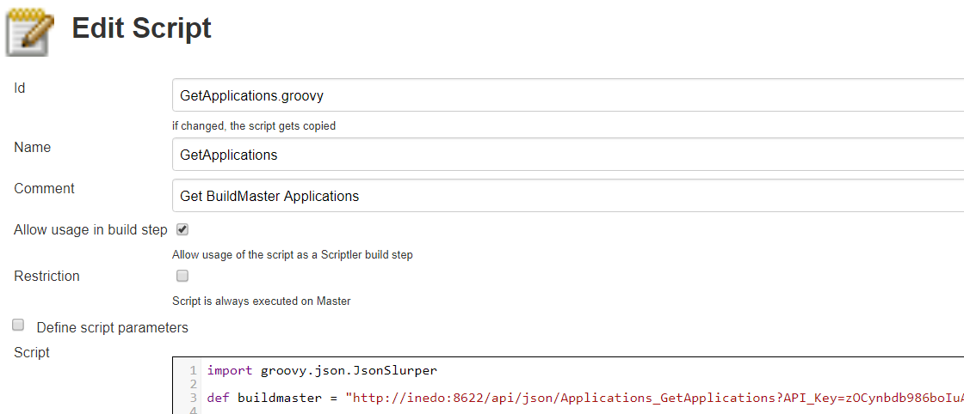

import groovy.json.JsonSlurper

def buildmaster = "http://inedo:8622/api/json/Applications_GetApplications?API_Key=zOCynbdb986boIuA6qqd"

def conn = buildmaster.toURL().openConnection()
def applications = [:]

if( conn.responseCode == 200 ) {
def results = new JsonSlurper().parseText(conn.content.text)

// to see results variable output uncomment the next line
// println results

results.each { data -> applications.put( data.Application_Id, data.Application_Name ) }
}

return applications.sort { a, b -> a.value <=> b.value }

GetReleases
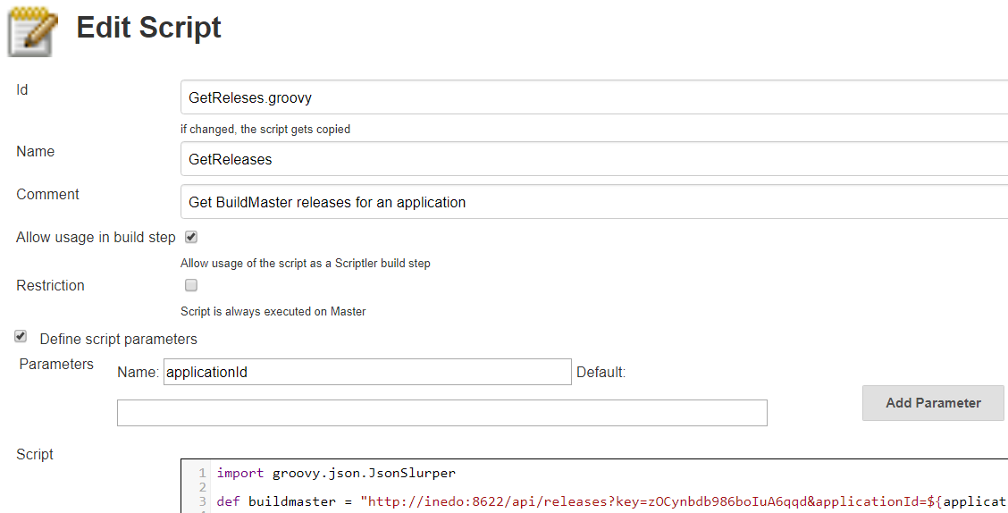

import groovy.json.JsonSlurper

def buildmaster = "http://inedo:8622/api/releases?key=zOCynbdb986boIuA6qqd&applicationId=${applicationId}&status=ACTIVE"

def conn = buildmaster.toURL().openConnection()
def applications = []

if( conn.responseCode == 200 ) {
def results = new JsonSlurper().parseText(conn.content.text)

// to see results variable output uncomment the next line
// println results

results.each { data -> applications.push( data.number ) }
}

return applications

Job Configuration
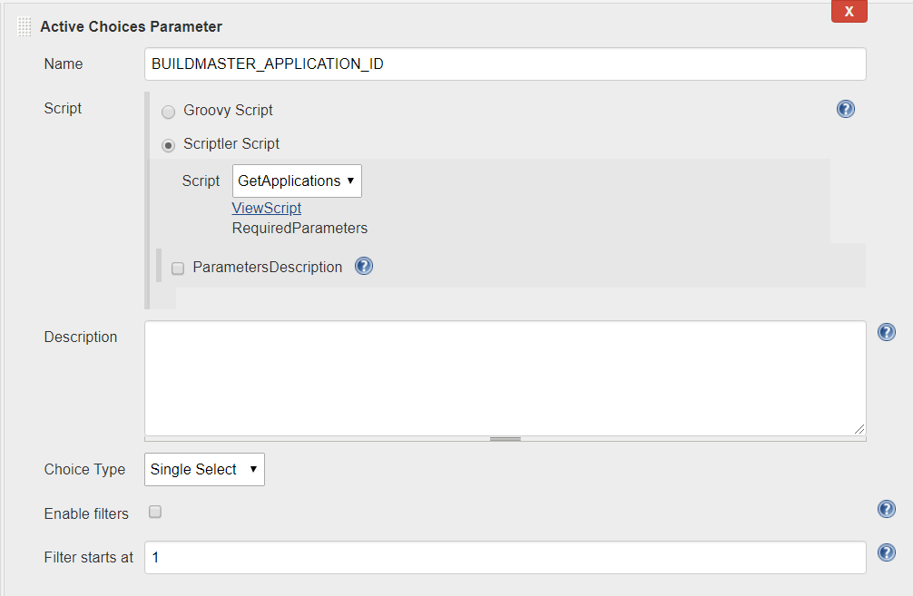

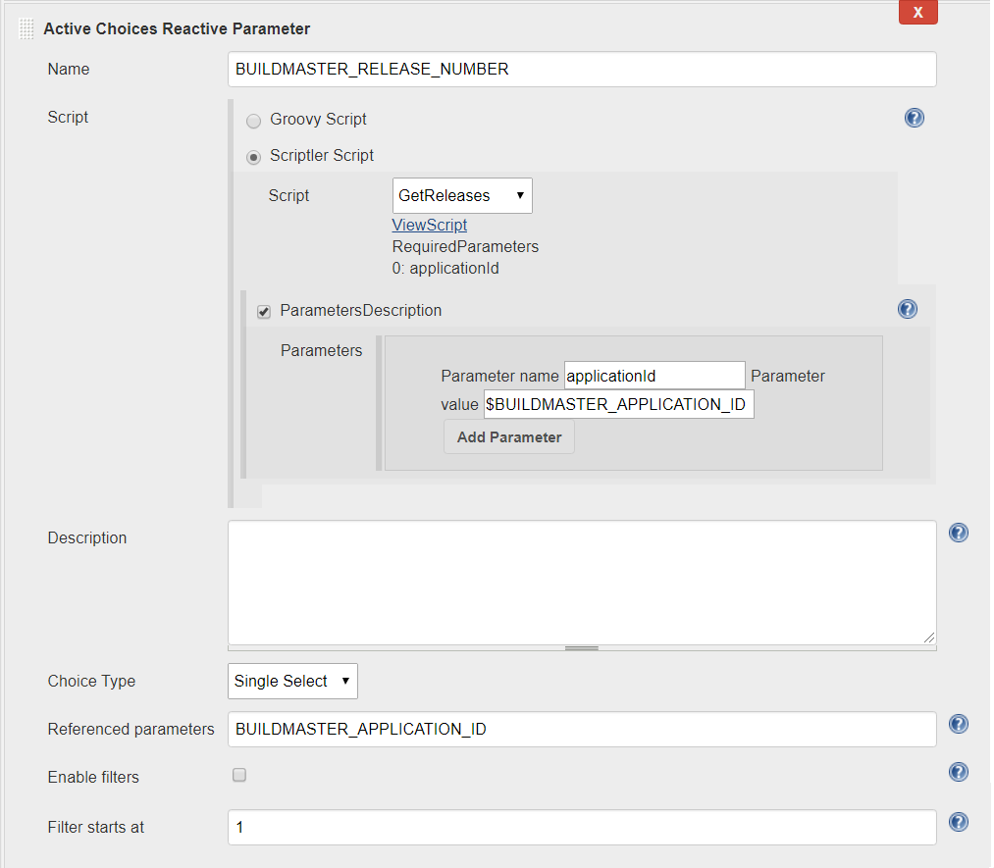

Note: to use groovy script option instead of the scriptler option replace the applicationId variable in the script to BUILDMASTER_APPLICATION_ID.

